Neurons and Synapses

1. Annotated diagram of a neuron

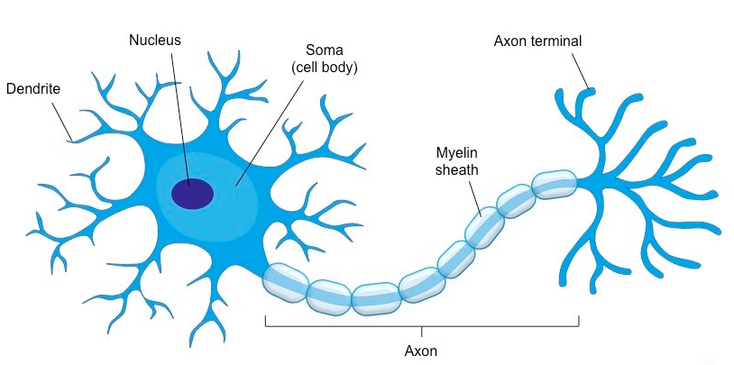

- Nucleus: biosynthetic center of the cell
- Dendrites: short, thick branched extensions of cytoplasm that are receptive sites
- Axon: Generates and conducts impulses, each neuron has one axon
- Myelin Sheath: fatty sheath that covers axon and increases speed of transmission of nerve impulses, made by Schwann cells
- Nodes of Ranvier: gaps in sheath that increase speed of transmission of nerve impulses

2. What is meant by resting membrane potential?

- Resting potential is the difference in charge across the membrane when a neuron is not firing.
- The inside of the neuron is more negative than the outside.
- Maintenance of a resting potential is an active process and is controlled by the sodium-potassium pump.
- 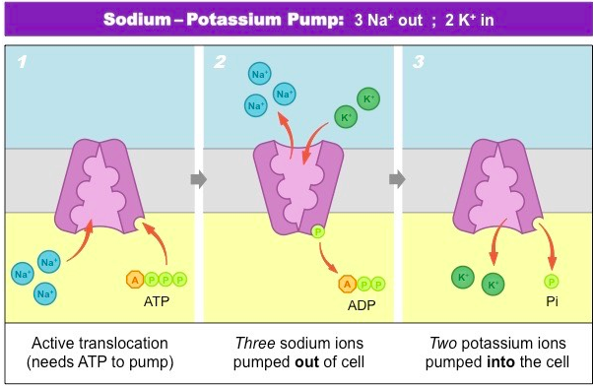
3. What is the role of the sodium potassium pump in maintaining the resting membrane potential?

- Pump is a protein that exchanges sodium and potassium. Expels 3 Na+ for every 2K+ admitted. This creates a gradient in which there are more positively charged ions outside of the cell and more negatively charged ions outside. This required ATP hydrolysis and is energy-dependent.

4. What is depolarization and how is it essential to creating an action potential?

- Depolarization is a sudden change in the membrane potential, usually from negative to positive charge.
- In depolarization, the response to a signal initiated by a dendrite opens the sodium channels of the axon. Na+ ions are more concentrated outside of the neuron and the opening of sodium channels causes a passive influx of sodium.
- Influx of sodium causes the action potential to become more positive.

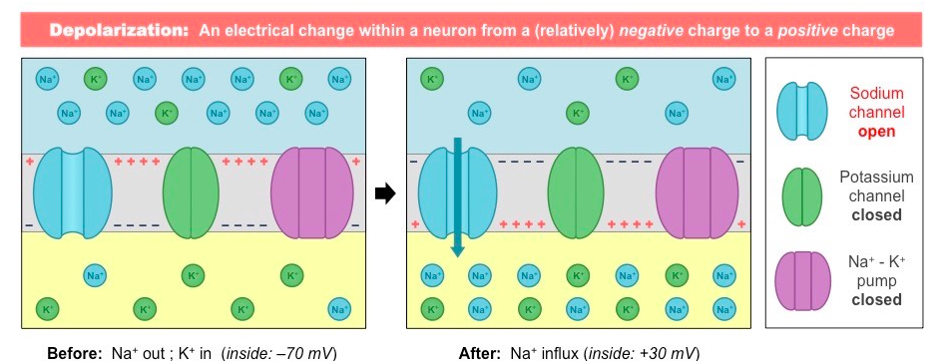
5. What is acetylcholine? How does it work? How is it broken down? How do neonicotinoid pesticides interfere with acetylcholine?

- Acetylcholine is a neurotransmitter used in many synapses such as neurons and muscle fibers.
- Once released into the synapse, it is broken down by acetylcholinesterase into choline and acetate. Choline is reabsorbed by presynaptic neuron where it is converted back to acetylcholine.
- Neonicotinoids bind to acetylcholine receptors but cannot break down. Binding is irreversible so it leads to paralysis and death.

Hormones, Homeostasis, and Reproduction

6. Draw an annotated diagram of spermatogenesis and oogenesis.
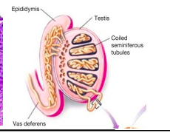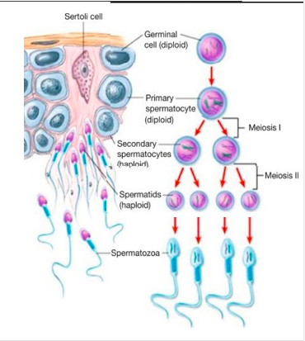

- Leydig Cells (located between tubules) are responsible for testosterone production
- Germinal epithelium (outermost layers in tubules) is where sperm production begins
- These sperm cells grow and divide via Mitosis to create primary spermatocytes
- The primary spermatocyte divides via Meiosis I to produce 2 haploid secondary spermatocytes
- The secondary spermatocytes divides by Meiosis II to produce spermatids
- Spermatids become involved with a Sertoli cell, which helps them develop into spermatozoa (these have tails!)
- Sperm detach and are carried out by fluid in the lumen
- 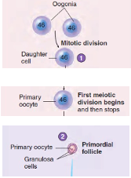
- Oocyte production begins with division of germ cells by mitosis, called oogonia
- 5th month of gestation: cells grown and begin Meiosis I but are stopped in Prophase I
- 7th month: cells are surrounded by granulosa cells and together called primordial follicles
- 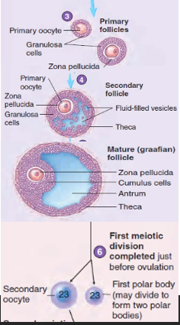
- Follicular Phase: primordial follicles are stimulated by FSH, causes granulosa cells to increase in number and secrete estrogen, now called primary follicles
- Secondary follicles are formed when fluid vesicles develop around oocyte and FSH levels rise
- Mature follicle forms when vesicles create 1 single vesicle
- Primary oocyte, with LH, completes Meiosis I, creates secondary oocyte and a polar body
- Primary oocyte completes Meiosis I with LH and creates a secondary oocyte and a polar body
- Ruptured follicle will develop in a corpeus luteum, which secretes key ovarian hormones
- Eventually corpus luteum will degenerate to form corpus albicans if no pregnancy is detected
- 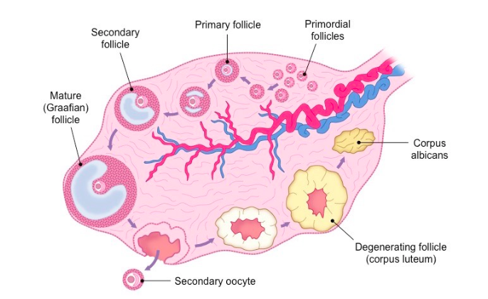
7. Outline the roles of the 4 major hormones in the female reproductive system
- Follicle Stimulating Hormone (FSH): stimulates ovarian follicle maturation and estrogen production
- Luteinizing Hormone (LH): triggers ovulation and stimulates progesterone production
- Estrogen and Progesterone: together they promote breast development and cyclic changes in endometrium
- Estrogen (alone) is responsible for maturation of reproductive organs and stimulates repair of uterus lining
- Progesterone (alone) causes thickening of the uterus lining and prepares uterine lining for implantation

Movement

8. Draw a labeled diagram of a sarcomere
- 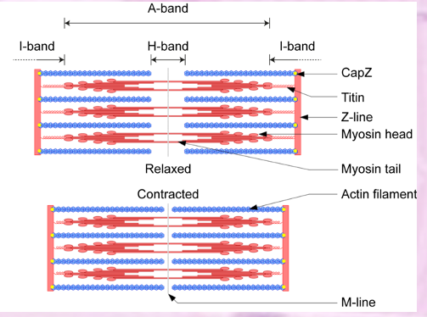
9. Given a light micrograph of skeletal muscle be able to label the various structures 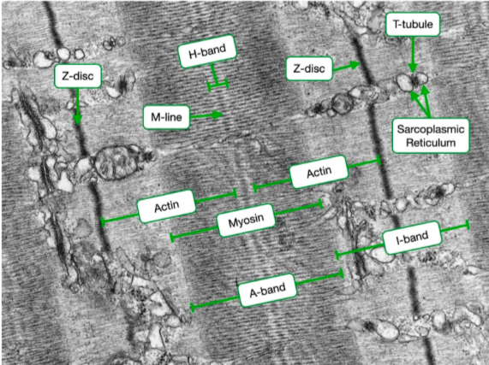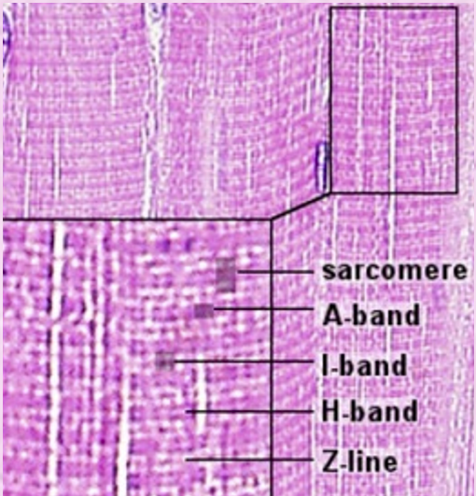

10. Outline calcium’s role in muscle contraction
- Action potential/nerve impulse/motor neuron triggers the release of acetylcholine into the motor end plate
- Acetylcholine initiates depolarization within the sarcolemma which causes the release of calcium from sarcoplasmic reticulum
- On actin, the binding sites for the myosin heads are covered by a blocking complex (troponin and tropomyosin)
- Ca2+ bind to troponin and refigure the complex, causing binding sites on actin to be exposed
- Myosin heads bind to binding sites/to actin and push actin inwards
11. Outline the process of muscle contraction

- Action potential arrives at the neuromuscular junction/depolarizes muscle cells
- Release of Ca2+ from the sarcoplasmic reticulum
- Ca2+ binding to troponin exposes actin to form cross-bridges with myosin heads
- Myosin heads push actin filament towards center of sarcomere so sarcomere becomes shorter
- Use of ATP to break cross-bridges/reset myosin heads

The Kidney and Osmoregulation

12. Describe the difference between osmoregulators and osmoconformers

- Describe the difference between osmoregulators and osmoconformers
- Osmoconformers maintain internal conditions that are equal to the osmolarity of their environment
- By matching internal osmotic conditions to the environment, osmoconformers minimize water movement in and out of cells
- Less energy is used to maintain internal osmotic conditions within an osmoconformer
- Osmoregulators keep their body’s osmolarity constant, regardless of environmental conditions
- While osmoregulation is a more energy-intensive process, it ensures internal osmotic conditions are always tightly controlled
- Osmoregulators can maintain optimal internal conditions whereas osmoconformers are affected by environmental conditions

13. Be able to draw an annotated diagram of a kidney
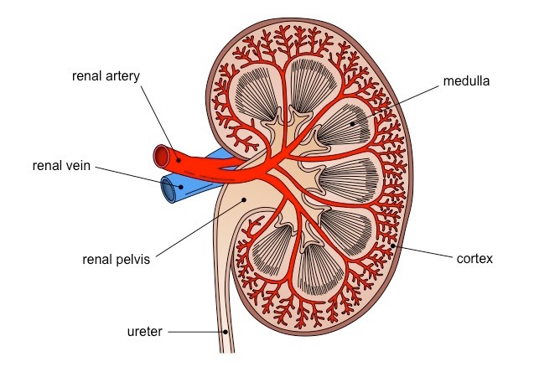
- Renal artery: branch of the aorta that brings blood into the kidney
- Renal vein: blood drains from the kidney and into the inferior vena cava
- Renal medulla: located deep to the cortex and contains the medullary pyramids
- Renal cortex: outermost layer containing the nephrons
- Renal pelvis: a continuation of the ureter
- The urine is transported from the kidneys via the ureter, where it is stored by the bladder prior to excretion
14. Describe how the kidney regulates osmolarity

- osmoregulation is maintenance of water balance of blood/tissues;
- loop of Henle creates hypertonic conditions in the medulla;
- water reabsorbed as filtrate passes through collecting duct;
- hypothalamus monitors/controls water balance/content of blood;
- controls secretion of ADH by (posterior) pituitary gland;
- ADH is released when blood too concentrated/too little water/hypertonic;
- ADH makes the collecting duct more permeable to water;
- due to more aquaporins;
- more water reabsorbed (in response to ADH);
- less water in urine/urine more concentrated/urine hypertonic;
- no/less ADH when blood too dilute/too much water/hypotonic;
- collecting duct less permeable/less water reabsorption/more water in urine;

